MBALE HEROES FC Catapult Report

Table of Contents
Introduction 3
Methodology 5
Key Concepts and Definitions in Physical Performance Analysis 6
2024/ 2025 Season Results 10
a) Match Day Usage 10
b) Player Usage 10
c) Club Metric Results 11
d) Top Player by Metric 11
e) Average Metrics Per Position 11
f) Percentage of Distance in Speed Zone 12
Average Metrics Per Matchday 12
Club Comparison 13
Comparison Against Season Averages 13
Comparison by Position 13
Club Metrics Trend 15
Positional Comparison in Each Speed Zone 15
Challenges 16
Future Plans 17
Conclusion 18

Introduction
In a strategic move to elevate domestic football standards, the Federation of Uganda Football Associations (FUFA) has invested substantially in Catapult GPS systems for clubs in the Uganda Premier League and FUFA Women Super League. By equipping teams with this state-of-the-art performance monitoring technology, FUFA demonstrates its commitment to player development, optimized match preparation, and sustained competitive excellence.
On September 13 2024, The FUFA President, Hon. Eng Moses Hashim Magogo said “The data collected from the devices will not only benefit the individual clubs but will also be shared with the national team coaches” He further went on to say “This will enable the coaches to select players based on their performance data and tailor training sessions to meet the specific needs of the national team”
The FUFA Research, Science and Technology (RST) has prepared this report focusing on BUL FC’s physical performance during the 2024/25 season, leveraging Catapult tracking data to deliver actionable insights. The major objectives are to:
- Quantify player workloads and intensity metrics
- Identify performance trends and outliers
- Inform training load management, injury prevention, and tactical planning
It is important to note that accurate analysis and subsequent interpretation depends on consistent device usage, precise session tagging, and timely data synchronization. Where gaps arise due to technical or logistical constraints, we highlight their impact on the analyses.
The report is organized into seven sections:
- Methodology: Data collection, cleaning, and analysis protocols
- Key Concepts and Definitions in Physical Performance Analysis
- Season Results: Individual and aggregated performance metrics (e.g., total distance, high-intensity efforts, accelerations)
- Club Comparison: BUL FC versus league averages to reveal relative strengths and areas for improvement
- Challenges: Recurring issues such as inconsistent device usage, mislabelled sessions, failure to upload, mismanagement of equipment
- Recommendations: Corrective measures including refresher training for Catapult operators, compliance to session naming protocols
- FUFA Future Plans: Strategic initiatives to enhance data integration, reporting consistency, and long-term performance monitoring across all top-tier clubs

Methodology
This report is based on data collected using the Catapult GPS player tracking system during the 2024/25 football season. The data includes performance metrics such as total distance covered, sprint distance, work ratio, player load, session availability, top speed, accelerations, decelerations, energy, power plays, impacts, total actions, distance per minute.
Data was collected and uploaded by trained club staff immediately after match sessions. The FUFA Research, Science & Technology (RST) unit oversaw the data collection process, ensuring sessions were split by halves, correctly labelled, and uploaded within seventy-two (72) hours post-match. Where necessary, additional follow-up was done with the club operators to correct mislabelled sessions or fill in missing data, ensuring full coverage of match data
The rigorous data cleaning process involved removing duplicates, resolving inconsistencies in player-pod assignments, and verifying that each match session met the minimum completeness threshold (e.g., full ninety (90) minutes, sufficient number of tracked players). Any session failing these criteria was excluded from further analysis to maintain consistency.
Once cleaned, data was aggregated by individual player and by club. Metrics were normalized to account for variations in match frequency, squad size, and overall data availability, and clubs with fewer than ten complete sessions were omitted from comparative analyses. All statistical summaries and visualizations were generated using Microsoft Excel, Power BI, R, and Python, following established RST workflows to ensure reliable, consistent benchmarks for technical review and long-term planning.

Key Concepts and Definitions in Physical Performance Analysis
This section gives a basic introduction to coaches, analysts and any other personnel who may be interested in physical performance data. It includes basic definitions and brief descriptions of the metrics and terminology used in the field. It also includes a section of why a club should be interested in their physical data.
Physical performance analysis: A method of collecting and interpreting data on a player’s movement and workload during training or matches. By measuring total and sprint distance, player load and work ratios, performance staff can monitor fitness adaptations, manage fatigue and implement injury-prevention protocols. In the Uganda Premier League, several clubs have used these insights to adjust training loads and optimise readiness for crucial fixtures.
Catapult GPS technology: A wearable athlete-monitoring system that integrates global positioning sensors with inertial measurement units (accelerometers, gyroscopes and magnetometers) to capture real-time movement data at high sampling rates. After each session, devices sync to base stations and upload into the Catapult software suite, which calculates metrics such as sprint profiles, accelerations and overall player load. Clubs use this information to tailor individual conditioning programs and track recovery between matchdays.
Volume: This refers to the total amount of physical work performed by a player over a training session or match. It captures aggregated outputs such as total distance covered or total number of accelerations and decelerations. Volume metrics help coaches gauge overall workload across a full session. Volume metrics include total distance, sprint distance, power plays, energy, impacts, accelerations, decelerations, total actions and player load.
Intensity: This refers to the rate or magnitude at which physical work is carried out. It measures how quickly or forcefully a player executes movements, for example distance per minute or accelerations per minute. Clubs use intensity metrics to adjust training drills for peak performance on matchdays. Intensity metrics include top speed, distance per minute, work ratio, power score, acceleration counts per minute and deceleration counts per minute.
Catapult Metrics and Their Meaning
Metric | Definition | Unit
Total Distance | The total number of kilometres a player covers while walking or running in a session. | Kilometres(km)
Sprint Distance | Distance covered while running above a set speed threshold of 25.2 km/h. | Metres(m)
Player Load | Measures the total load on a player’s body in a session or game.
Top Speed | The maximum speed (km/h) a player reaches in a session. | Kilometres per Hour (km/h)
Impacts | The number of high-force events (e.g., collisions, landings, tackles | Count
Power Plays | The number of intense actions a player was involved in | Count
Distance per Minute | Intensity measure showing meters covered every minute. | Metres per Minute (m/min)
Work Ratio | Ratio of high-intensity work time to total time | Percentage
Max Acceleration/Deceleration | Peak rate of speed change | Metres per second per second (m/s/s)
Power Score | Measures the power output used per kilogram of your weight. | Watts per Kilogram (w/kg)
Energy | A measure of how much energy is expended during a game or training session. | Kilocalories(kcal)

Why should a club be interested in these metrics?
- Monitoring these metrics allows coaches to identify fatigue or underperformance before it leads to injury or decline in form. For example, a sudden drop in total actions or distance per minute can signal that a player is not recovering adequately between sessions.
- These measures enable position-specific benchmarks, ensuring defenders, wingers, midfielders and strikers train to the demands of their roles rather than a generic team standard. Comparing work ratio and power score across similar positions helps staff tailor workloads and maintain optimal performance levels.
- Individualized training programs are designed using these data points. If a player’s accelerations per minute fall below the team standard, practice drills can be adjusted to include more high-intensity runs and recovery phases, thereby bridging the gap to match demands.
- Objective feedback derived from metrics like player load and total impacts supports both performance reviews and recovery protocols. Quantitative insights align player perceptions of exertion with actual workload, guiding nutrition, rest and physiotherapy interventions for efficient return to peak readiness.

Speed Zones
There are five speed zones in Catapult. For the 2024/25 season, these were the zones and thresholds that were used. Note that these zones will be regularly reviewed by the RST team and adjusted at the end of the season to promote steady improvement.
Zone | Thresholds (km/h) | Intensity | Descriptor
Zone 1 | 0 – 3.6 | Very Low | Standing, Walking at Recovery Pace
Zone 2 | 3.61 – 10.8 | Low to Moderate | Jogging and Easy Runing
Zone 3 | 10.81 – 18 | Moderate to High | Running
Zone 4 | 18.1 – 25.2 | High | High Speed Running
Zone 5 | 25.21 - 43.2 | Maximal | Sprinting

2024/ 2025 Season Results

Match Day Usage
Number of Matches Analysed: 12
Number of Matches Uploaded: 14
Percentage of Matches Uploaded: 46.67%
Match Day | Opponent Club | Number of Players Monitored | Average Session Duration (min) | Match Result | Match Location
MD 1 |  | 0 | 0
MD 2 | SC Villa | 7 | 103.2 | Win | Home
MD 3 | Wakiso Giants FC | 11 | 108 | Win | Home
MD 4 |  | 0 | 0
MD 5 | Lugazi FC | 8 | 104.7 | Draw | Away
MD 6 | KCCA FC | 11 | 96.1 | Loss | Home
MD 7 | Police FC | 10 | 100.3 | Loss | Away
MD 8 | Bul FC | 4 | 100.4 | Draw | Home
MD 9 |  | 0 | 0
MD 10 | Soltilo Bright Stars FC | 10 | 96 | Win | Home
MD 11 | Kitara FC | 8 | 99.8 | Loss | Away
MD 12 | UPDF FC | 7 | 101.7 | Draw | Away
MD 13 | Vipers SC | 9 | 100.6 | Loss | Home
MD 14 | Maroons FC | 11 | 88.1 | Loss | Away
MD 15 | NEC FC | 10 | 90 | Loss | Home

Player Usage
Player Name | Position | Match Days Analysed
Adrian Sserungo | Defender | 7
Amos Etoju | Midfielder | 6
Andrew Kawooya | Forward | 6
Ceasor Olega | Defender | 8
Cosia Waiswa | Forward | 3
David Kakeeto | Forward | 9
Davis Ssekajja | Midfielder | 7
Edgar William Katumba | Forward | 6
Etou Gideon Andrew | Defender | 3
Hakim Musabbah | Forward | 1
Hakiramu Muzanyi | Forward | 9
Hassan Kato | Midfielder | 8
Hilary Adima | Midfielder | 3
Isaac Ofoyrwoth | Forward | 3
Jeremy Matata | Forward | 8
Malik Bironse | Forward | 10
Musa Malunda | Defender | 3
Oni Bashir | Midfielder | 4
Samson Kasozi | Defender | 1
Umar Kyebatala | Forward | 1

Club Metric Results
Metric | Total | Max | Min | Mean | Std Dev
Distance(km) | 870.35 | 12.15 | 2.56 | 8.21 | 2.89
Sprint Distance(m) | 86,432.86 | 2,048.54 | 4.37 | 815.4 | 444.44
Power Plays | 6,050 | 114 | 1 | 57.08 | 28.3
Energy(kcal) | 107,373.13 | 1,771.05 | 261.66 | 1,012.95 | 391.4
Impacts | 538 | 23 | 0 | 5.08 | 4.35
Accelerations | 38,305 | 611 | 95 | 361.37 | 138.11
Decelerations | 37,053 | 612 | 98 | 349.56 | 134.13
Total Actions | 75,358 | 1,223 | 195 | 710.92 | 271.97
Player Load |  | 597.36 | 137.76 | 382.64 | 120.16
Top Speed |  | 34 | 18.15 | 29.02 | 3.07
Distance per Minute |  | 126.52 | 24.48 | 83.52 | 29.48
Power Score |  | 20.16 | 3.67 | 13.31 | 4.84
Work Ratio |  | 120.31 | 11.41 | 69.23 | 28.43
Acceleration Counts per Min | 389.57 | 6.28 | 0.94 | 3.68 | 1.41
Deceleration Counts per Min | 376.87 | 6.22 | 0.94 | 3.56 | 1.37

Top Player by Metric
Metric | Player | Value | Match Day
Distance | Hakim Musabbah | 12.15 | MD 10
Sprint Distance | Umar Kyebatala | 2,048.54 | MD 2
Power Plays | Umar Kyebatala | 114 | MD 2
Energy | Amos Etoju | 1,771.05 | MD 11
Impacts | Samson Kasozi | 23 | MD 15
Accelerations | Etou Gideon Andrew | 611 | MD 3
Decelerations | Etou Gideon Andrew | 612 | MD 3
Total Actions | Etou Gideon Andrew | 1,223 | MD 3
Player Load | Hassan Kato | 597.36 | MD 10
Top Speed | Jeremy Matata | 34.00 | MD 13
Distance per Minute | Hakim Musabbah | 126.52 | MD 10
Power Score | Jeremy Matata | 20.16 | MD 10
Work Ratio | Hakim Musabbah | 120.31 | MD 10
Acceleration Counts per Min | Hassan Kato | 6.28 | MD 10
Deceleration Counts per Min | Hassan Kato | 6.22 | MD 10

Average Metrics Per Position
Position | Defenders | Forwards | Midfielders
Distance | 8.61 | 7.83 | 8.65
Sprint Distance | 778.55 | 824.42 | 826.34
Power Plays | 55.36 | 54.95 | 62.68
Energy | 1129.54 | 937.39 | 1072.49
Impacts | 4.95 | 5.52 | 4.29
Accelerations | 386.77 | 338.64 | 386.86
Decelerations | 372.73 | 327.95 | 374.57
Total Actions | 759.5 | 666.59 | 761.43
Player Load | 402.29 | 366.14 | 400.2
Top Speed | 29.44 | 28.97 | 28.81
Distance per Minute | 87.82 | 80.03 | 87.13
Power Score | 13.98 | 12.76 | 13.89
Work Ratio | 70 | 66.8 | 73.49
Acceleration Counts per Min | 3.94 | 3.46 | 3.9
Deceleration Counts per Min | 3.8 | 3.35 | 3.78

Percentage of Distance in Speed Zone
Position | Zone 1 | Zone 2 | Zone 3 | Zone 4 | Zone 5
Defenders | 11.28 | 50.04 | 29.64 | 7.68 | 1.36
Midfielders | 9.27 | 45.43 | 35.75 | 8.65 | 0.9
Forwards | 10.43 | 49.74 | 29.31 | 8.91 | 1.61

Average Metrics Per Matchday
Metric | MD 2 | MD 3 | MD 5 | MD 6 | MD 7 | MD 8 | MD 10 | MD 11 | MD 12 | MD 13 | MD 14 | MD 15
Distance | 9.2 | 8 | 7.5 | 8 | 7.3 | 9.8 | 9.7 | 7.7 | 8.5 | 8.3 | 7.8 | 7.9
Sprint Distance | 1029.4 | 752.2 | 614.7 | 886 | 695.3 | 963.9 | 926.8 | 788.4 | 814.3 | 828 | 825.8 | 766.8
Power Plays | 67.9 | 54.2 | 46.6 | 58.5 | 51.3 | 65.2 | 69.1 | 52.5 | 53.4 | 59.8 | 54.7 | 56.3
Energy | 1092.3 | 964.6 | 869 | 1052 | 880.8 | 1267 | 1240.8 | 988 | 1069.3 | 991.9 | 965.7 | 937.1
Impacts | 7.3 | 3.7 | 5.2 | 4.4 | 6.2 | 7 | 6.3 | 3.2 | 4.7 | 3.8 | 3.5 | 7.1
Accelerations | 397.7 | 356.2 | 331.4 | 355.3 | 319.5 | 437.2 | 434.5 | 334.1 | 361.7 | 371.9 | 329.7 | 357.6
Decelerations | 386.6 | 342.5 | 323.5 | 340 | 311.6 | 431.5 | 421.1 | 320.6 | 340.1 | 360.6 | 319.5 | 349.3
Total Actions | 784.3 | 698.7 | 654.9 | 695.3 | 631.1 | 868.8 | 855.6 | 654.8 | 701.9 | 732.4 | 649.2 | 706.9
Player Load | 427.1 | 375.7 | 364.1 | 367.6 | 352.3 | 433 | 442.6 | 359.6 | 389.9 | 393.7 | 358.5 | 370.7
Top Speed | 29.9 | 28.6 | 27.5 | 29.8 | 29 | 30 | 29 | 29.7 | 29.1 | 30.1 | 28.2 | 28.3
Distance per Minute | 88.9 | 74.3 | 71.3 | 83.8 | 72.5 | 97.6 | 101.4 | 76.9 | 83.8 | 82.3 | 88.9 | 87.3
Power Score | 14.3 | 11.8 | 11.2 | 13.4 | 11.5 | 15.5 | 16.2 | 12.3 | 13.2 | 13.2 | 14.1 | 14
Work Ratio | 71.4 | 60.6 | 55.6 | 71.7 | 60.3 | 82.5 | 89.3 | 63 | 68.1 | 68.7 | 71.8 | 72.4
Accs/Min | 3.9 | 3.3 | 3.2 | 3.7 | 3.2 | 4.4 | 4.5 | 3.3 | 3.6 | 3.7 | 3.7 | 4
Decs/Min | 3.7 | 3.2 | 3.1 | 3.5 | 3.1 | 4.3 | 4.4 | 3.2 | 3.3 | 3.6 | 3.6 | 3.9

Club Comparison

Comparison Against Season Averages
Metric | Club Average | Season Average | Percentage Difference
Distance | 8.21 | 8.51 | -3.53
Sprint Distance | 815.4 | 843.54 | -3.34
Power Plays | 57.08 | 60.22 | -5.21
Energy | 1012.95 | 1040.78 | -2.67
Impacts | 5.08 | 6.29 | -19.24
Accelerations | 361.37 | 397.08 | -8.99
Decelerations | 349.56 | 381.1 | -8.28
Total Actions | 710.92 | 778.19 | -8.64
Player Load | 382.64 | 391.02 | -2.14
Top Speed | 29.02 | 29.59 | -1.93
Distance per Minute | 83.52 | 86.75 | -3.72
Power Score | 13.31 | 13.96 | -4.66
Work Ratio | 69.23 | 72.41 | -4.39
Acceleration Counts per Min | 3.68 | 4.05 | -9.14
Deceleration Counts per Min | 3.56 | 3.89 | -8.48

Comparison by Position
Metric | Defenders | Forwards | Midfielders
Club distance | 8.61 | 7.83 | 8.65
Season distance | 9.03 | 7.56 | 8.66
Percentage Difference | -4.7 | 3.65 | -0.13
Club sprint distance | 778.55 | 824.42 | 826.34
Season sprint distance | 845.89 | 874.85 | 814.71
Percentage Difference sprint distance | -7.96 | -5.77 | 1.43
Club power plays | 55.36 | 54.95 | 62.68
Season power plays | 59.83 | 58.11 | 62.45
Percentage Difference | -7.47 | -5.45 | 0.37
Club energy | 1129.54 | 937.39 | 1072.49
Season energy | 1111.27 | 928.41 | 1050.07
Percentage Difference energy | 1.64 | 0.97 | 2.13
Club impacts | 4.95 | 5.52 | 4.29
Season impacts | 6.03 | 7.41 | 5.68
Percentage Difference | -17.9 | -25.49 | -24.54
Club total accelerations | 386.77 | 338.64 | 386.86
Season total accelerations | 429.52 | 336.12 | 409.06
Percentage Difference | -9.95 | 0.75 | -5.43
Club total decelerations | 372.73 | 327.95 | 374.57
Season total decelerations | 412.44 | 323.14 | 391.9
Percentage Difference | -9.63 | 1.49 | -4.42
Club total actions | 759.5 | 666.59 | 761.43
Season total actions | 841.96 | 659.25 | 800.96
Percentage Difference | -9.79 | 1.11 | -4.94
Club player load | 402.29 | 366.14 | 400.2
Season player load | 414.91 | 350.11 | 396.52
Percentage Difference | -3.04 | 4.58 | 0.93
Club top speed | 29.44 | 28.97 | 28.81
Season top speed | 29.83 | 30.55 | 28.5
Percentage Difference | -1.29 | -5.18 | 1.1
Club distance per min | 87.82 | 80.03 | 87.13
Season distance per min | 91.91 | 77.38 | 88.39
Percentage Difference | -4.44 | 3.41 | -1.43
Club power score | 13.98 | 12.76 | 13.89
Season power score | 14.75 | 12.55 | 14.18
Percentage Difference | -5.24 | 1.69 | -2.04
Club work ratio | 70 | 66.8 | 73.49
Season work ratio | 77.06 | 62 | 75.51
Percentage Difference | -9.15 | 7.74 | -2.66
Club acceleration counts per min | 3.94 | 3.46 | 3.9
Season acceleration counts per min | 4.37 | 3.44 | 4.17
Percentage Difference | -9.79 | 0.43 | -6.47
Club deceleration counts per min | 3.8 | 3.35 | 3.78
Season deceleration counts per min | 4.2 | 3.31 | 4
Percentage Difference | -9.47 | 1.16 | -5.46

Club Metrics Trend
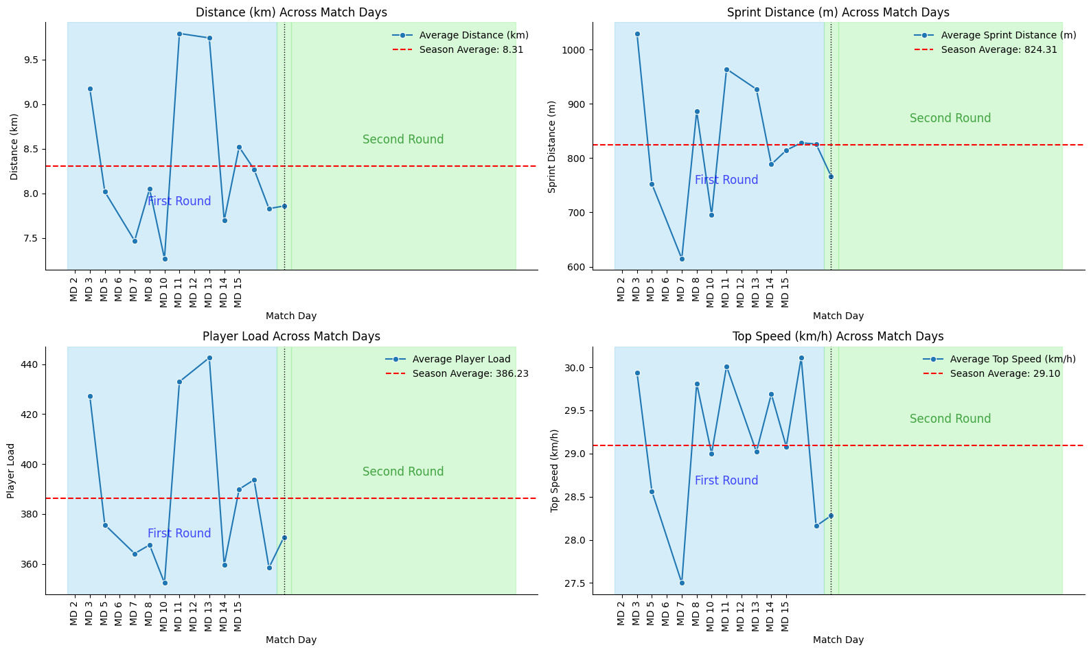

Positional Comparison in Each Speed Zone
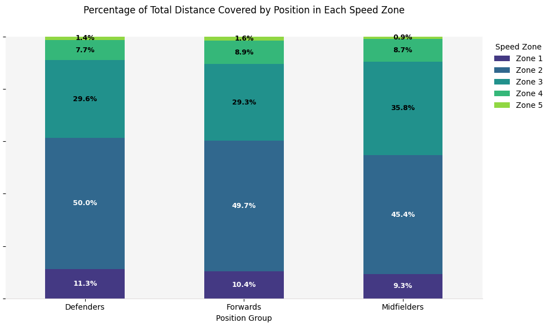

Challenges
The challenges outlined below represent common operational and data management issues observed across multiple clubs using Catapult systems. These are not specific to any one club, but rather reflect broader trends that can impact the consistency, accuracy, and usefulness of performance data. From equipment mismanagement to gaps in staff training and session documentation, these hurdles can hinder the full potential of Catapult insights. Clubs experiencing similar difficulties or seeking tailored support are encouraged to contact the FUFA Research, Science and Technology (RST) Team, who can provide club-specific guidance and help implement effective solutions.
The challenges are outlined below:
- Inconsistent use of Catapult devices across games, leading to incomplete match coverage
- Failure to upload sessions at all or delays in syncing which creates backlogs
- Misclassification of training sessions as games, and vice versa
- Incorrect session naming, making it difficult to locate or aggregate sessions
- Improper session splitting (e.g., durations recorded as < 90 minutes or > 120 minutes, incorrect splits for substituted players)
- Mismanagement of equipment leading to loss or damage
- Limited expertise in translating raw Catapult outputs into tactical or physiological insights
- Club staff not fully trained on usage and upload procedures, resulting in missed or late uploads

Future Plans
This section outlines the strategic initiatives FUFA intends to roll out to maximize the impact of Catapult data across Uganda’s top tier leagues. These federation-led actions build on the 2024/25 season insights and are designed to standardize workflows, deepen analysis, and support both club staff and players. For club-specific implementation advice or technical assistance, please contact the FUFA Research, Science and Technology (RST) unit.
- Conduct regular visits to the clubs to monitor equipment usage and share club specific insights.
- Organise regular training workshops for club performance staff on Catapult device management, data procedures and software analytics to ensure consistent, high-quality data capture.
- Leverage catapult data to inform nutritional guidance, tailoring macronutrient ratios to individual training demands and recovery needs.
- Introduce individual performance benchmarks for every playing position (right back, centre forward, defensive midfielder, etc.) with detailed threshold bands for both volume and intensity at club level.
- Integrate Catapult metrics with tactical and technical analysis by linking GPS outputs to technical or tactical data generated by other systems, thereby providing coaches with combined insights into player movement patterns and team strategy.
- Carry out Research projects using catapult data along other data

Conclusion
We extend our sincere thanks to every coach, performance staff member and analyst for their dedication in collecting and interpreting Catapult data this season. Your hard work has laid a solid foundation for evidence-based decision-making across fitness, recovery and match preparation.
All Catapult outputs and associated player information will be handled in strict accordance with the FUFA data privacy and security policy, ensuring confidentiality, ethical use and compliant storage. This protocol safeguards both individual rights and the integrity of our performance analysis.
As we move into the next season, we look forward to your feedback and stand ready to support your club through FUFA’s Research, Science and Technology unit. You can reach us via email on fufa.rst@gmail.com

